AI Careeer Councellor – Project Report

Project By- Tanvi Chiman

Abstract

Career guidance is an essential step in shaping an individual’s future, but access to professional counselling is often limited. This project, AI Career Counsellor, aims to provide basic career recommendations using **Natural Language Processing (NLP)** techniques. The system is designed around five fundamental professions – **Journalist, Data Scientist, Doctor, Lawyer, and Entrepreneur –** and utilizes a **CSV dataset** containing descriptions and skills for these roles. User input is processed through NLP pipelines to extract relevant features and matched against the dataset using similarity measures. The application is implemented with **FastAPI** as the backend, **HTML and CSS** for the frontend, and deployed on **Railway** for online accessibility. Testing was initially performed in **Google Colab** using ngrok. Results demonstrate that the system can map user interests and skills to one of the predefined professions effectively. This project highlights the integration of  **NLP and web technologies** to deliver a scalable and accessible career counselling solution, with potential for expansion to more professions and real-world applications.

Introduction

Career selection is a critical decision, but many students lack access to professional counselling. To address this, I built an **AI Career Counsellor** that provides career suggestions based on user input. The system is designed to recommend one of five core professions **– Journalist, Data Scientist, Doctor, Lawyer, Entrepreneur** – by analyzing natural language input from the user.

The project demonstrates the integration of **NLP, Machine Learning, and Web Development** to solve a real-world problem.

Objectives

* To build a career guidance tool using **NLP techniques**.
* To utilize a **CSV dataset** containing profession details and required skills.
* To provide real-time recommendations through a **web interface**.
* To deploy the project for public accessibility

Methodology

3.1 **Dataset** - A CSV file was prepared containing the least professions with their descriptions, skills, and career highlights.

3.2 **NLP & Model** - Input text preprocessing: tokenization, contraction handling, stopword removal. - Vectorization using transformer-based embeddings. - Cosine similarity to map user input with profession descriptions in the CSV.

3.3 **Frontend** - HTML & CSS form where users enter their interests/skills.

3.4 **Backend** - FastAPI for handling requests and responses. - Model loading via joblib for efficient execution.

3.5 **Deployment** - Tested on Google Colab using ngrok for quick demos. - Fully deployed on Railway, making it accessible via a public URL.

Tools & Technologies

* Python - FastAPI (backend framework)
* HTML, CSS (frontend)
* Transformers, PyTorch (NLP embeddings)
* Joblib, Pandas (data handling and model persistence)
* Railway & Ngrok (deployment/testing)

Result

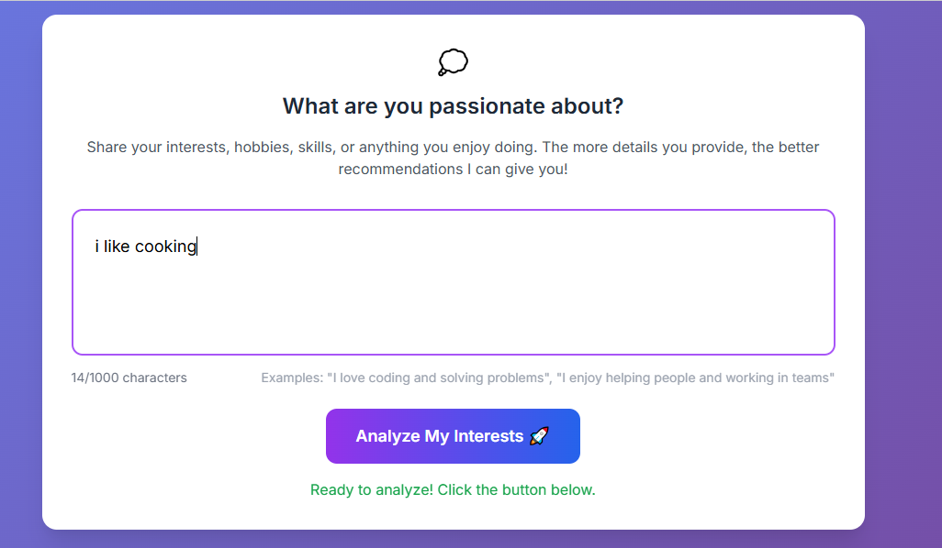

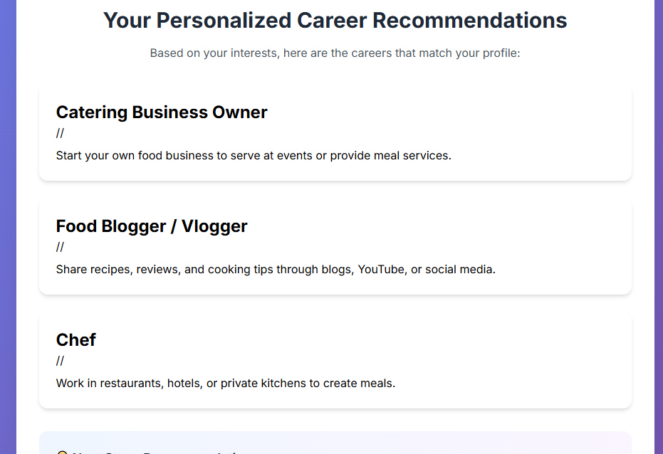

Conclusion

This project demonstrates how NLP can provide accessible and affordable career counselling. By combining CSV data, NLP models, and web deployment, the system successfully recommends suitable professions. This work can be extended into a full-fledged AI counsellor for larger datasets and industries.